*cs-2020-01785b­­­­­­_revised version _Supporting Information*

**Understanding the Improved Activity of Dendritic Sn1Pb3 Alloy for the CO2 Electrochemical Reduction: A Computational-Experimental Investigation**

Mengyang Fan,1,¶ Mohammad J. Eslamibidgoli,2,3¶, Xinwei Zhu,3 Sébastien Garbarino,1,4

Ana C. Tavares,1 Michael Eikerling,2,3 and Daniel Guay1*

1 INRS-Énergie, Matériaux Télécommunications

1650 Lionel-Boulet Boulevard, P.O. 1020,

Varennes, QC, Canada J3X 1S2

2 Department of Chemistry, Simon Fraser University,

8888 University Drive, Burnaby, BC, Canada V5A 1S6

3 Institute of Energy and Climate Research (IEK-13) –

Theory and Computation of Energy Materials,

Forschungszentrum Jülich GmbH, Jülich, Germany 52425

4 PRIMA Québec,

505 Boulevard Maisonneuve Ouest, Montréal, QC, Canada H3A 3C2

¶ These authors contributed equally to the work

* Corresponding author (guay@emt.inrs.ca)

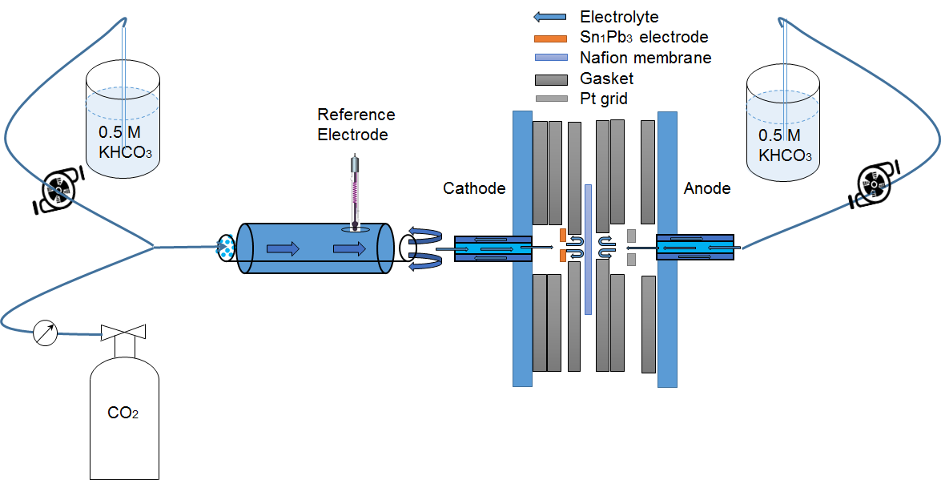

Figure S1 Schematic illustration of the flow cell system.

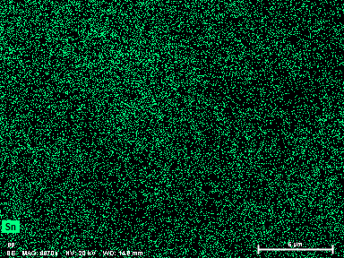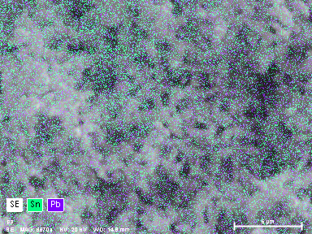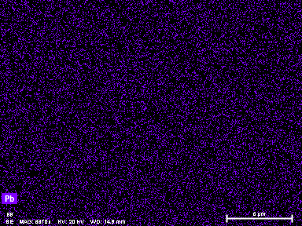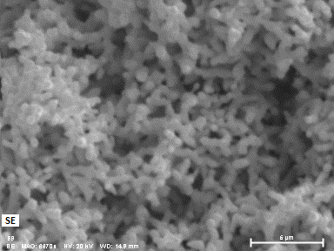

**(a)**

**(c)**

**(b)**

**(d)**

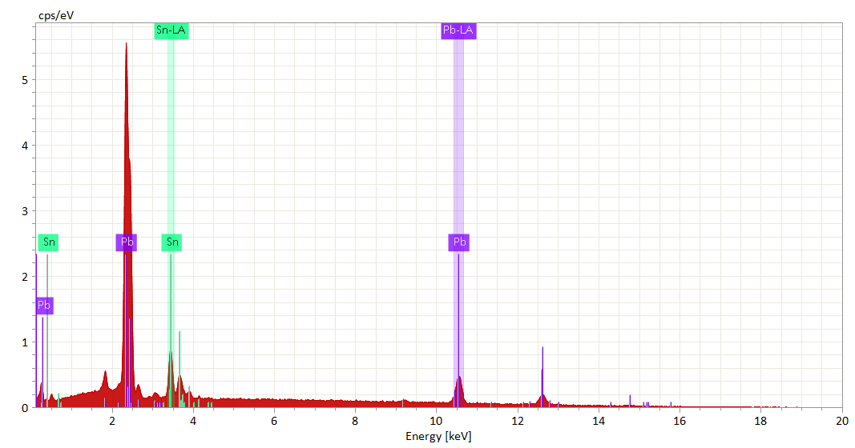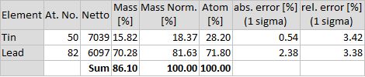

**(e)**

Figure S2 In (a-e), SEM and EDX mappings of dendritic Sn1Pb3 alloy. Pb: purple dots and lines. Sn: green dots and lines.



Figure S3 Double layer capacitance measurements of (a) dendritic Pb and (b) dendritic Sn1Pb3 alloy.

The *LSV* curves shown in Fig. 3a were normalized by the electrochemical active surface area (*EASA*), which was determined from CVs measurements performed at different scan rates in Ar-saturated 0.5 M KHCO3. The double layer capacitance of dendritic Pb was 1150 F cm-2geo, and 585 F cm-2geo for dendritic Sn1Pb3 alloy. The bare Pb substrate was used as reference (specific capacitance of 40 F cm-2geo) to estimate the roughness factor, which are 28.8 for dendritic Pb and 14.6 for dendritic Sn1Pb3 alloy.



Figure S4 In (a), chronopotentiostatic curves of dendritic Pb electrode recorded in Ar-saturated 0.5 M KHCO3. In (b), Faradaic Efficiency as function of electrode potential.

The electrolysis of both dendritic Sn1Pb3 alloy and dendritic Pb were conducted in CO2-saturated 0.5 M KHCO3 electrolyte and the electrolysis currents are shown in Figure S4a. As shown in Figure S4b, the *FE*formate of dendritic Pb is 46% at -1.16 V and 74% at -1.26 V *vs* SHE. At these potentials, H2 and CO were not detected (the *FE* for these products is zero).

To figure out why the total *FE* of dendritic Pb is different from 100% even if only formate is detected, we carried out potentiostatic electrolyses in Ar-saturated 0.5 M KHCO3 electrolyte (Figure S4a). In the Ar-saturated electrolyte, no products (formate, H2 and CO) were detected even if a significant charge is passed through the system. At -1.16 and -1.26 V *vs* SHE, the total charge in the Ar-saturated electrolyte, *Q*Ar, accounts for 51% and 24% of the total charge recorded for dendritic Pb in the CO2-saturated electrolyte, respectively. This charge is associated with the reduction of lead oxide present at the surface of dendritic Pb. As shown in Figure S4b, the sum of the faradic efficiency for the reduction of lead oxide and *FE*formate adds up to a value very close to 100%.



Figure S5 Texture coefficient, *TC*(hkl), analysis of the dendritic deposits. This analysis was performed using the XRD patterns shown in Figure 2.

The value of the texture coefficient (*TC*(hkl)) was calculated by the inverse pole intensity technique using the following equation:

where *I(hkl)* is the reflected intensity from *(hkl)* diffracted planes of Pb and Sn1Pb3, *IR(hkl)* is the intensity from *(hkl)* planes of polycrystalline Pb and Sn1Pb3, and *n* is the total number of measured planes. TC*(hkl)* is proportional to the number of grains orientated with this facet. *TC*(hkl) > 1 denotes that the sample has more crystallites with (hkl) facets than polycrystalline Pb and Sn1Pb3, whereas *TC*(hkl) < 1 suggests the synthesized sample has less crystallites in that (hkl) direction than polycrystalline Pb and Sn1Pb3. It was hypothesized that the relative intensity of the XRD peaks of polycrystalline *fcc* Sn1Pb3 are identical to that of polycrystalline *fcc* Pb.

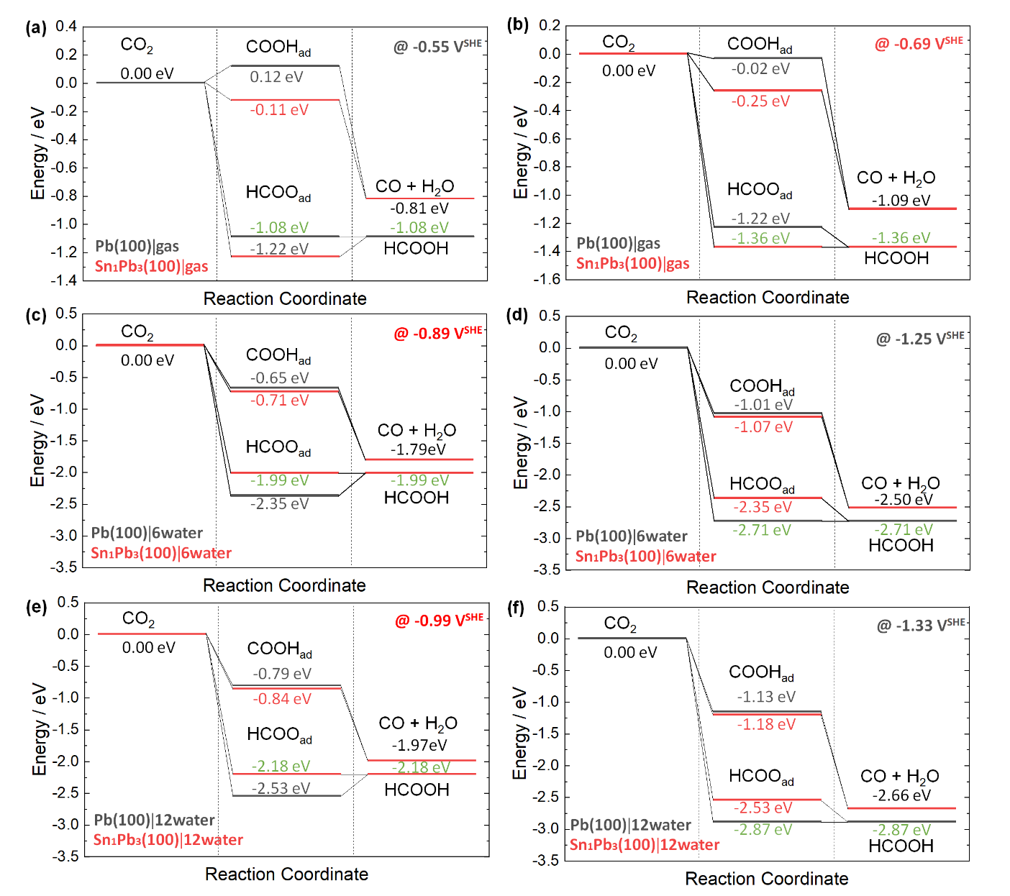

Figure S6 Energy diagrams for CO2 reduction. In (a), gas phase conditions at -0.55 V. In (b), gas phase conditions at -0.69 V. In (c), with 6 water molecules at -0.89 V. In (d), with 6 water molecules at -1.25 V. In (e), with 12 water molecules at -0.99 V. In (f), with 12 water molecules at -1.33 V. The black curves stand for Pb(100) surface, while the red curve stands for Sn1Pb3(100).

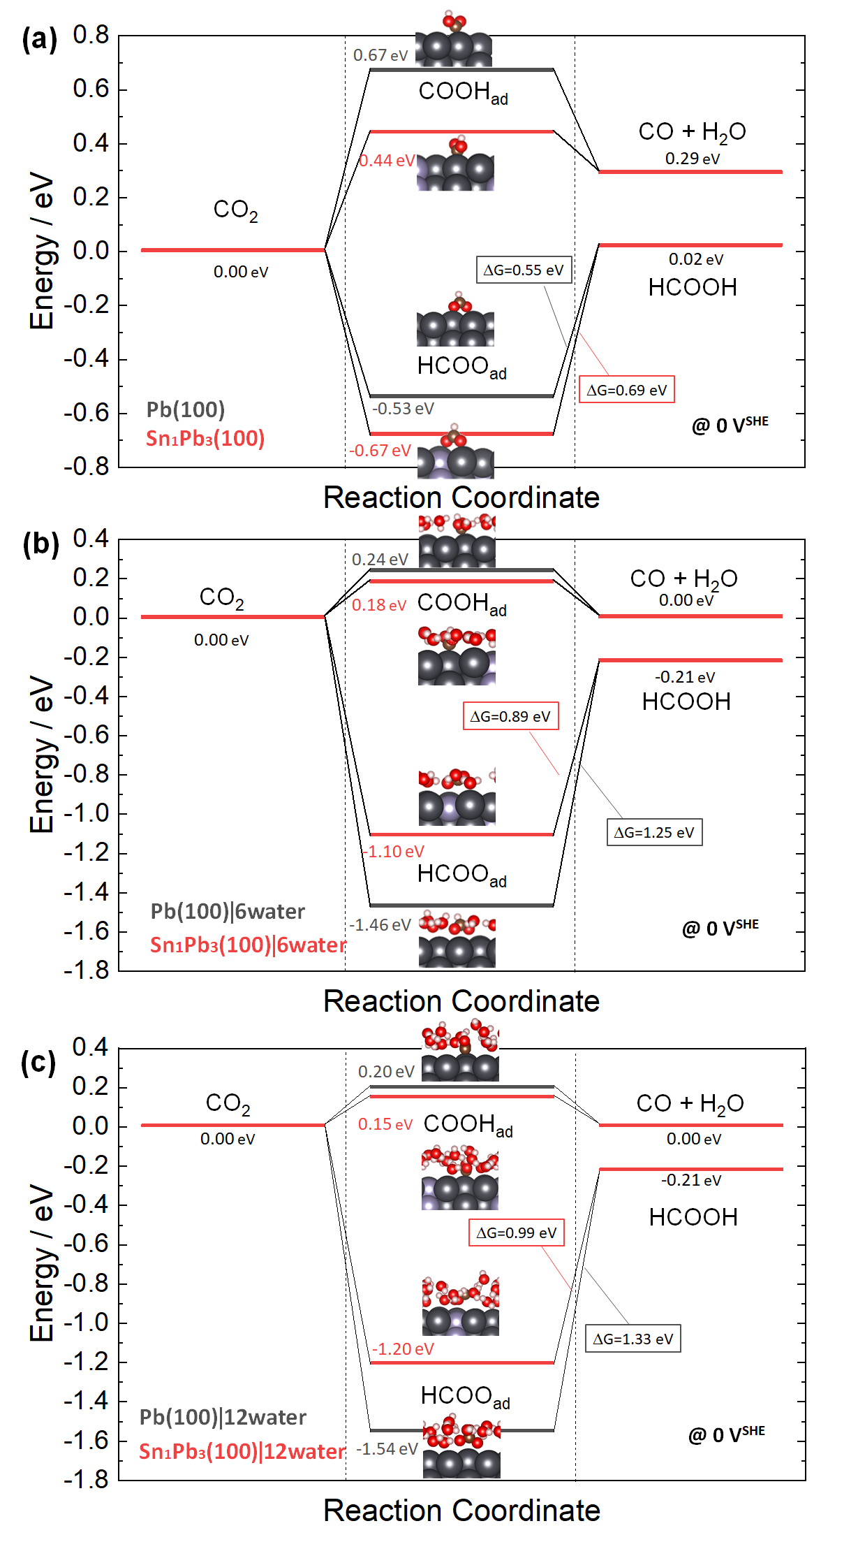

Figure S7 Energy diagrams for CO2 reduction. In (a), gas phase conditions at 0 V. In (b), with 6 water molecules at 0 V. In (c), with 12 water molecules at 0 V.

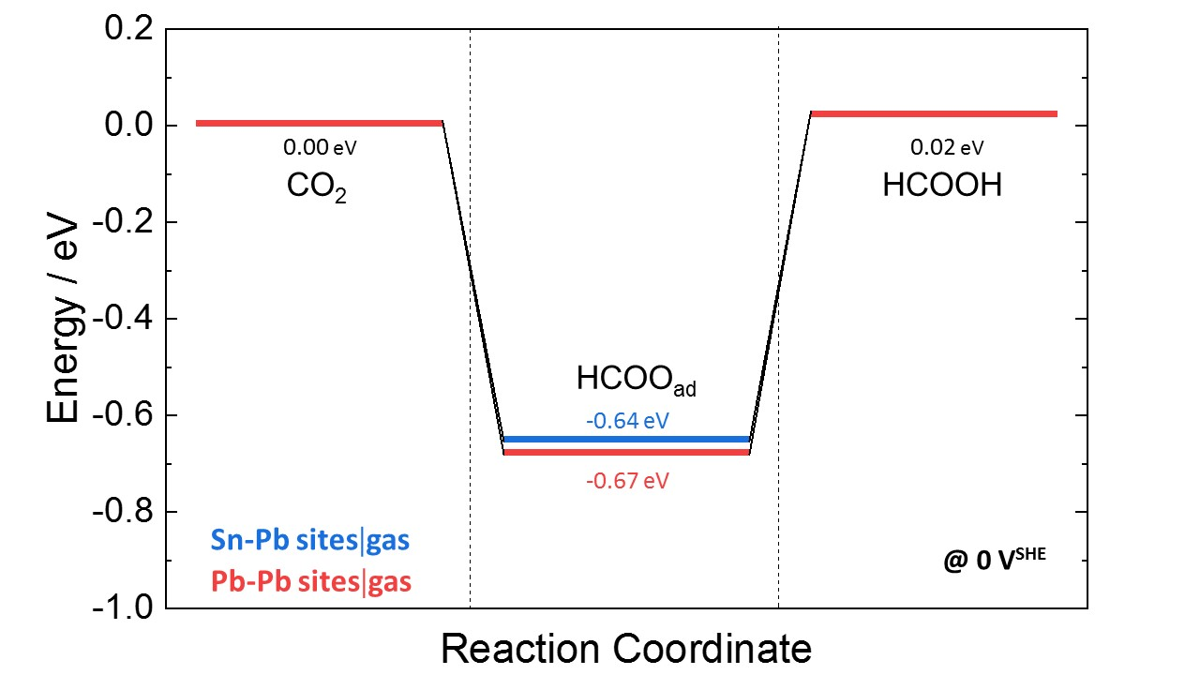

**(a)**

**(b)**

**(c)**

## 

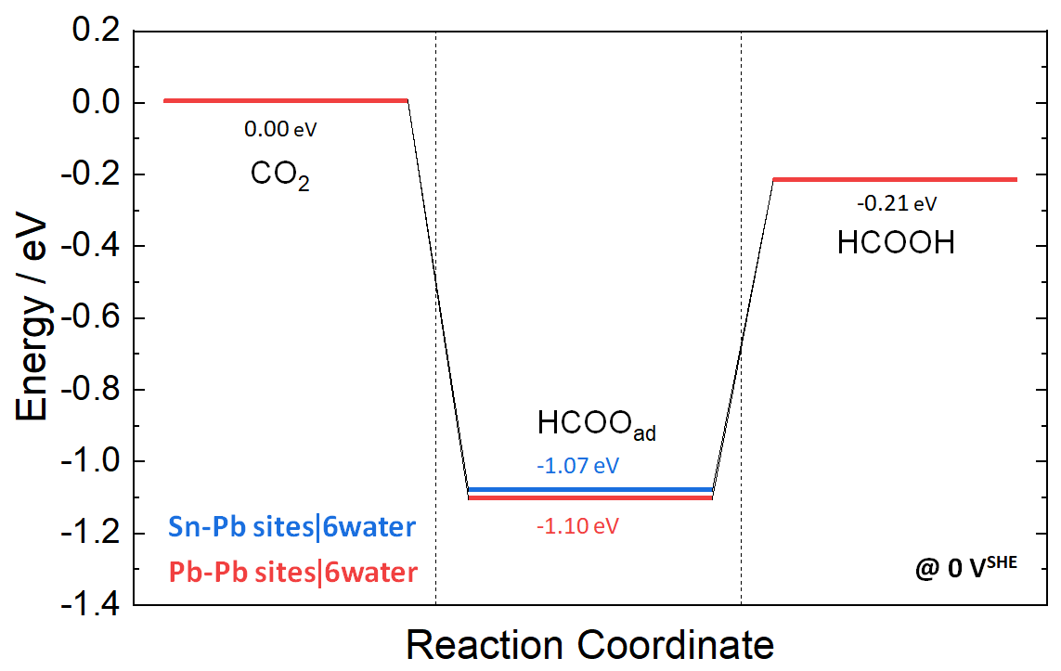

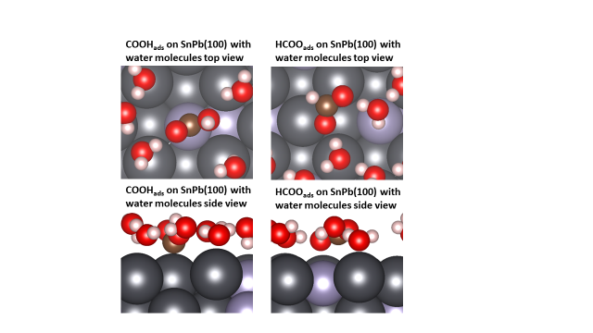

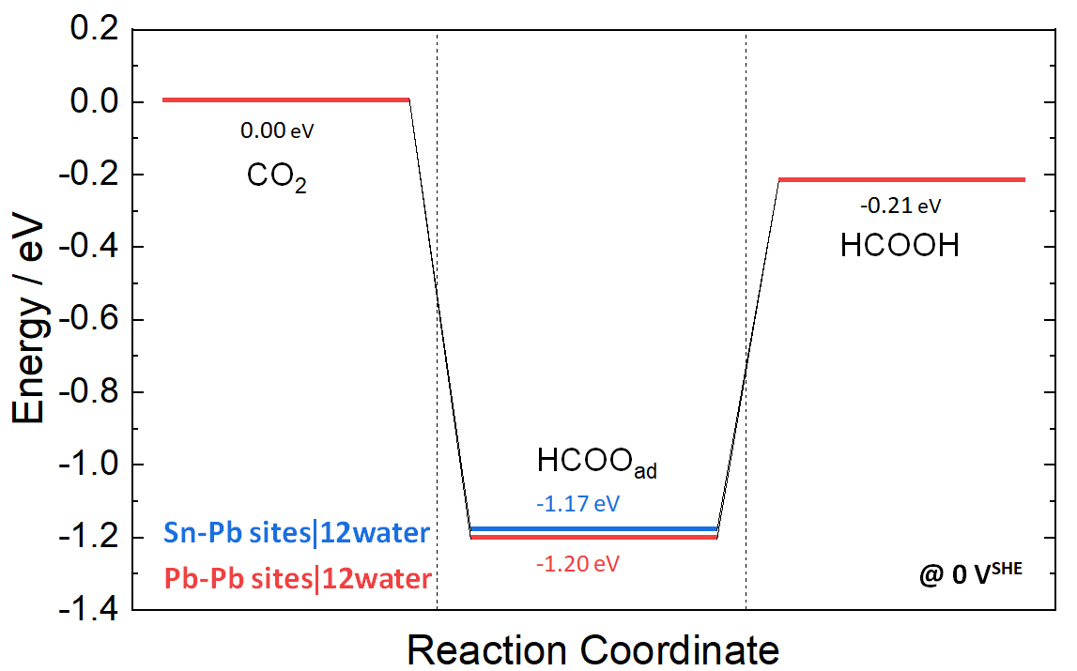

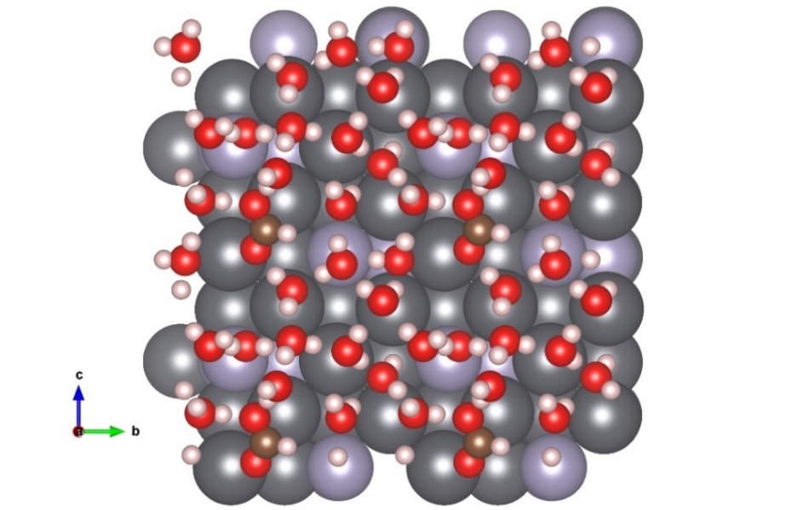

Figure S8 Binding Energy of HCOO* adsorbed at different adsorption sites on Sn1Pb3(100) surface. In (a), gas phase conditions. In (b), with 6 water molecules. In (c), with 12 water molecules. The blue curves stand for adsorbed HCOO* at Sn-Pb sites, while the red curve stands for HCOO* adsorbed on Pb-Pb sites.

Figure S9 3D charge density difference along with the most stable configurations of HCOO* in the presence of 12 water molecules on (a) Pb(100) and (b) Sn1Pb3(100). For clarity, only a restricted number of water molecules are shown around HCOO*.

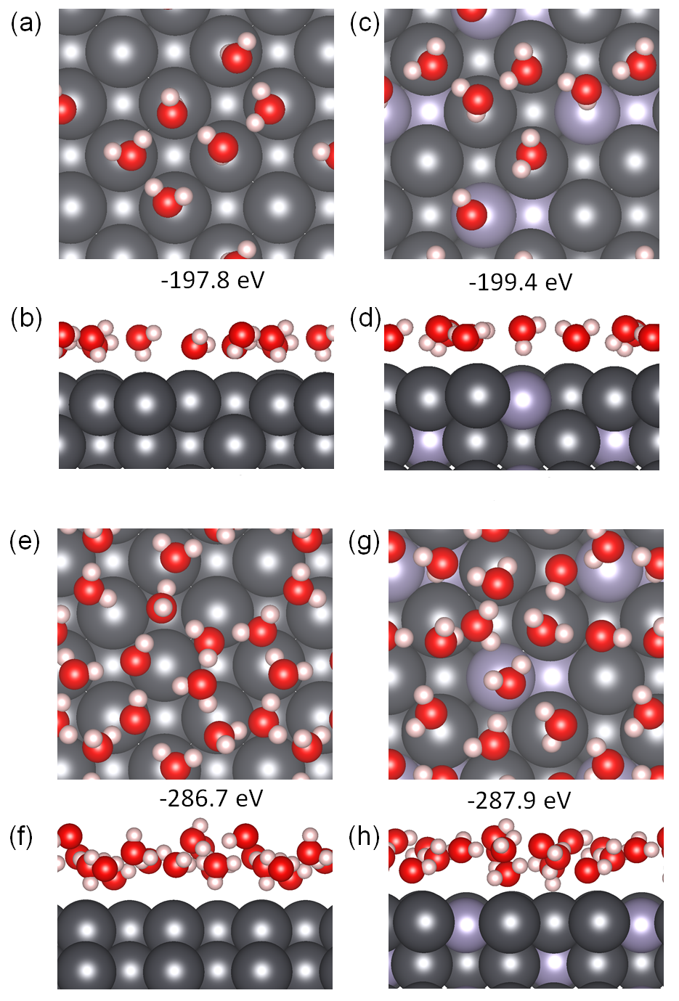

Figure S10 Optimized structures adopted by 6 water molecules when in contact with (a, b) Pb(100), and (c, d) Sn1Pb3(100) surfaces. Optimized structures adopted by 12 water molecules when in contact with (e, f) Pb(100), and (g, h) Sn1Pb3(100) surfaces.

Optimized structures of 6 and 12 water molecules in the absence of any other adsorbates. The binding energy of the 12 water molecules on Pb(100) and Sn1Pb3(100) surfaces is = -286.7 eV and -287.9 eV, respectively.

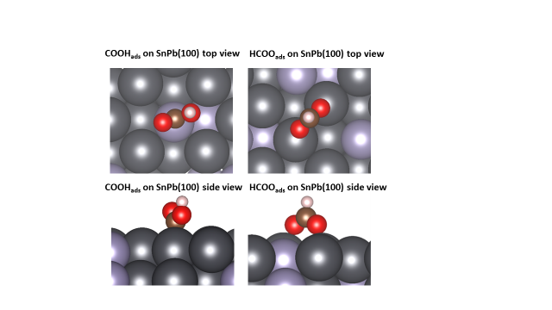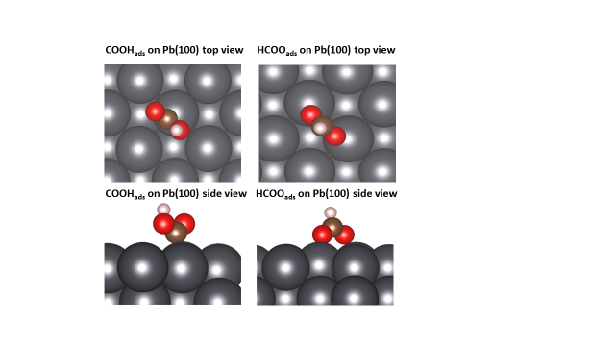

**(a1)**

**(a2)**

**(b1)**

**(b2)**

**(c1)**

**(c2)**

**(d1)**

**(d2)**

**(e1)**

**(e2)**

**(f1)**

**(f2)**

**(g1)**

**(g2)**

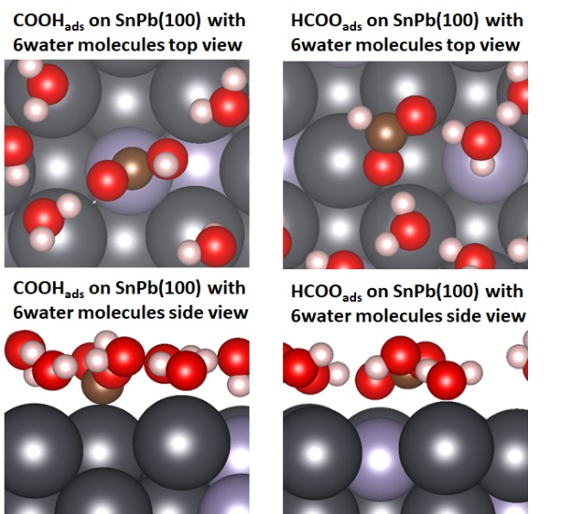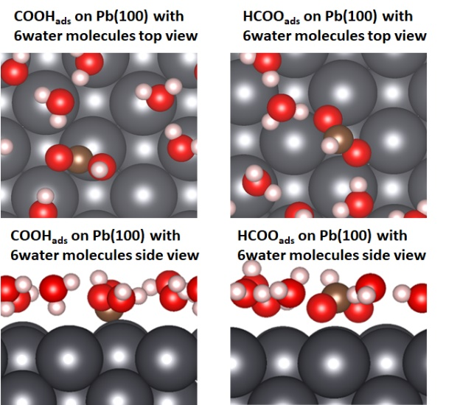

**(h1)**

**(h2)**

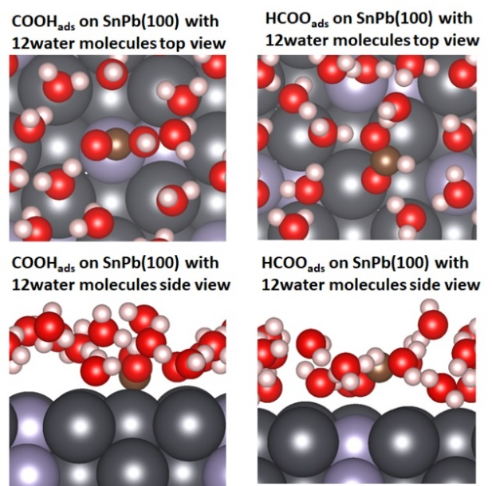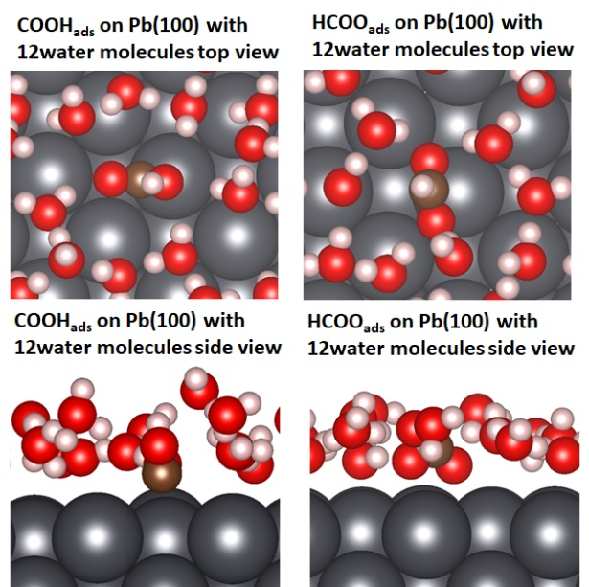

**(j1)**

**(j2)**

**(k1)**

**(k2)**

**(l1)**

**(l2)**

**(i1)**

**(i2)**

Figure S11 Optimized structures in gas phase condition: (a1-2) COOH* on Pb(100), (b1-2) HCOO* on Pb(100), (c1-2) COOH* on Sn1Pb3 (100) and (d1-2) HCOO* on Sn1Pb3(100). Optimized structures with 6 water molecules: (e1-2) COOH* on Pb(100), (f1-2) HCOO* on Pb(100), (g1-2) COOH* on Sn1Pb3(100), and (h1-2) HCOO* on Sn1Pb3(100). Optimized structures with 12 water molecules: (i1-2) COOH* on Pb(100), (j1-2) HCOO* on Pb(100), (k1-2) COOH* on Sn1Pb3(100), and (l1-2) HCOO* on Sn1Pb3(100).

|  |  |  |
| --- | --- | --- |
| **Table S1 Onset potential *vs* SHE of different electrodes** | | |
| Electrodes | CO2-saturated  0.5 M KHCO3 | Ar-saturated  0.5 M KHCO3 |
| Dendritic Pb | -1.09 | -1.50 |
| Dendritic Sn1Pb3 alloy | -1.01 | -1.33 |

|  |  |  |  |  |  |
| --- | --- | --- | --- | --- | --- |
| **Table S2 Comparison of the performance of CO2 electroreduction towards formate on Pb based materials** | | | | | |
| Catalysts | Electrolyte | FEformate | Overpotential / V | *J*  / mA cm-2 | Reference | |
| Pb-granule | 0.2 M K2CO3 | 94% | 1.1 | 0.41 | 2 | |
| Oxide  derived Pb | 0.5 M NaHCO3 | 97% | 1.01 | 1 | 3 | |
| Pb | 1 M KHCO3 | 97% | 0.99 | 7.5 | 4 | |
| Amine  modified Pb | 1 M KHCO3 | 97% | 1.09 | 6 | 5 | |
| **Dendritic Sn1Pb3 alloy** | **1 M KHCO3** | **92%** | **0.7** | **17.4** | **This work** | |

|  |  |  |  |
| --- | --- | --- | --- |
| **Table S3 Thermodynamic quantities of gas-phase molecules (eV). The adsorption energy, zero-point energy (ZPE), and entropy (TS)** | | | |
|  | Ead  (eV) | ZPE  (eV) | TS  (eV) |
| CO2 | -23.15 | 0.31 | 0.1 |
| H2O | -14.25 | 0.56 | 0.1 |
| CO | -15.22 | 0.13 | 0.09 |
| H2 | -6.72 | 0.27 | 0.09 |
| HCOOH | -30.02 | 0.89 | 0.11 |

The energy of CO2, CO, and HCOOH was corrected by calculated values of -0.10 eV, -0.29 eV, and -0.23 eV respectively, owing to solvent stabilization. ZPE and TS were taken from an ealier ealier report by Klinkona *et al.*1

**Table S4** Comparison of the binding energies of HCOO* in parallel and perpendicular configurations at Pb(100) and Sn1Pb3(100) surface. Twelve water molecules were included in the DFT calculations in all cases.

|  |  |  |
| --- | --- | --- |
| Surface | HCOO* configuration | Binding Energy |
| Pb(100) | **Perpendicular** | **-1.54 eV** |
|  | Parallel | -1.24 eV |
| Sn1Pb3(100) | Perpendicular | -0.75 eV |
|  | **Parallel** | **-1.20 eV** |

**References**

(1) Klinkova, A.; De Luna, P.; Dinh, C.-T.; Voznyy, O.; Larin, E. M.; Kumacheva, E.; Sargent, E. H., Rational Design of Efficient Palladium Catalysts for Electroreduction of Carbon Dioxide to Formate. *ACS Catal.* **2016,** *6* (12), 8115-8120.

(2) Köleli, F.; Balun, D., Reduction of CO2 under high pressure and high temperature on Pb-granule electrodes in a fixed-bed reactor in aqueous medium. *Appl. Catal. A-Gen.* **2004,** *274* (1-2), 237-242.

(3) Lee, C. H.; Kanan, M. W., Controlling H+ vs CO2 Reduction Selectivity on Pb Electrodes. *ACS Catal.* **2015,** *5* (1), 465-469.

(4) Fan, M.; Garbarino, S.; Botton, G. A.; Tavares, A. C.; Guay, D., Selective electroreduction of CO2 to formate on 3D [100] Pb dendrites with nanometer-sized needle-like tips. *J. Mater. Chem. A* **2017,** *5* (39), 20747-20756.

(5) Zouaoui, N.; Ossonon, B. D.; Fan, M.; Mayilukila, D.; Garbarino, S.; de Silveira, G.; Botton, G. A.; Guay, D.; Tavares, A. C., Electroreduction of CO2 to formate on amine modified Pb electrodes. *J. Mater. Chem. A* **2019,** *7* (18), 11272-11281.